March Newsletter
Welcome everyone and let’s start to savour the onset of Spring and, hopefully, much less rain! What a dreary month February turned out to be!
February began with our ‘Bring a Book’ session hosted by Alistair. With over forty members in attendance, I was surprised to see no-one had even chosen the same author! As a flavour of the books chosen, these were the titles and authors from my table: Secret of Secrets by Dan Brown, The Wind in the Willows by Kenneth Grahame, Complete Short Stories of Hercule Poirot by Agatha Christie, Exposure by Helen Dunsmore, The Complaints by Ian Rankin, The Wolves of Willoughby Chase by Joan Aiken, and Guns, Germs and Steel by Jared Diamond. Quite a mixed bag, I am sure you will agree. This was followed by a very interesting morning of talks: Bristol by Judy and unusual pub names by Tony. Thanks to both for a very entertaining morning. Andrew Finch, our outside speaker, gave a fascinating talk on Billy Butlin. So many facts we never knew and so many famous people who began their careers as ‘redcoats’ – Steven Mulhern, Dave Allen, Des O'Connor, Charlie Drake, Ted Rogers, Roy Hudd and Jimmy Tarbuck to name but a few!
It was my last meeting as chair on 23rd February and I now pass the lead on to Lynn Roff and wish her all the best. The flowers and wine I received were wonderful and so unexpected – thank you.
Our best wishes go to Derek as he embarks on his treatment. Hope to see you back at U3A very soon Derek.

Afternoon tea at Royal British Legion
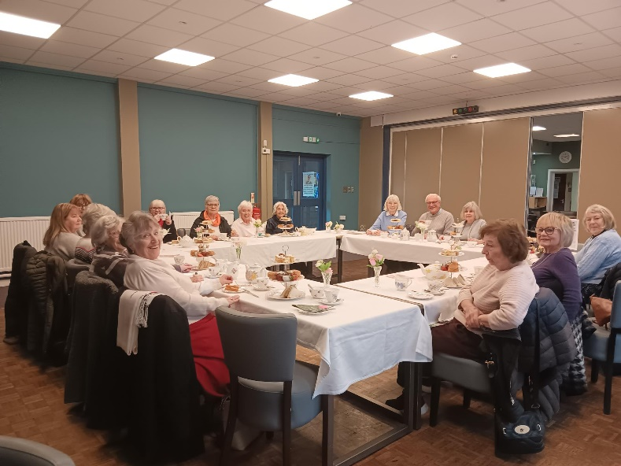This took place on Tuesday 17th February and was attended by seventeen members. It was our first afternoon tea here, and we were not disappointed. The afternoon tea was well worth the £14 we paid and the home-made scones were particularly delicious. In the words of Judy:
“It was a very enjoyable afternoon tea; the scones were excellent. It was excellent value for money”.

Walking group
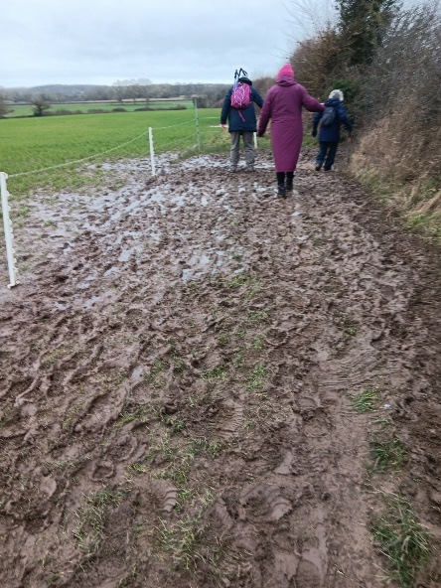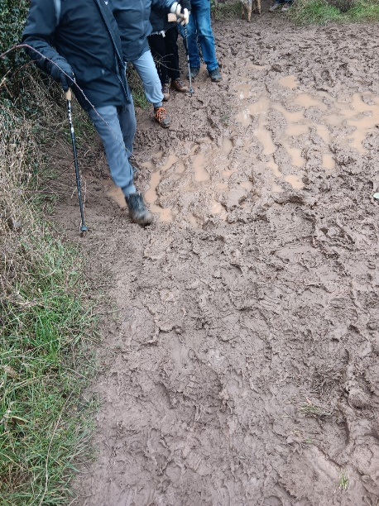Our most recent walking group meet was on Friday 20th February. We met in Kenilworth. I feel bound to mention it because of the mud! Shoes turned to brown, trousers splashed and wet, a few slips and slides and, even the soles of shoes lost! Plenty of smiles along the way. A meal at the Queen & Castle afterwards, soon sorted us all out.

U3A cluster meetings
Last month, Doug Cross wondered what had become of the U3A cluster meetings. Well, I am pleased to say, with a little bit of investigation on my part, these have now been resurrected and the first meeting was held on 26th February. Here is an update from the meeting:
U3a Cluster meeting February 26th 2026.
(The cluster consists of all 14 u3a groups within Solihull area)
This was my first Cluster meeting after becoming Chairman three days previously and I was surprised at how diverse the different u3a groups are.
One of the key issues raised was the difficulty in finding new committee members. One solution was to just ask people to take on designated jobs without necessarily being a member of the committee.
One group had a waiting list and was respectfully advised that u3a is all inclusive and therefore having a waiting list was against charity regulations.
A good point made was that there should be a welcome pack for new members. One u3a went as far as to give members an elaborate membership card. Any thoughts?
U3a is changing and it is difficult to attract younger members. One group (not in our area) no longer has monthly meetings as their membership is dwindling.
The most obvious fact that I took away was how very different the large groups are from the smaller groups. Dorridge u3a, with a membership of 600, only has 20% of its members attending the core group meetings. Table tennis seems to be the order of the day in that u3a.
It became obvious that we are a friendly group and one Chairman came up to me and told me that the key word I used was friendship.
I came away rejoicing the fact that our small group is both welcoming and friendly and that giving our own talks was both unusual and beneficial.
Well done Solihull u3a.
Lynn Roff.
Thanks Lynn, good to know that our U3A is doing well!
What special things happened in March, I hear you ask
March in History
Oxford and Cambridge boat race
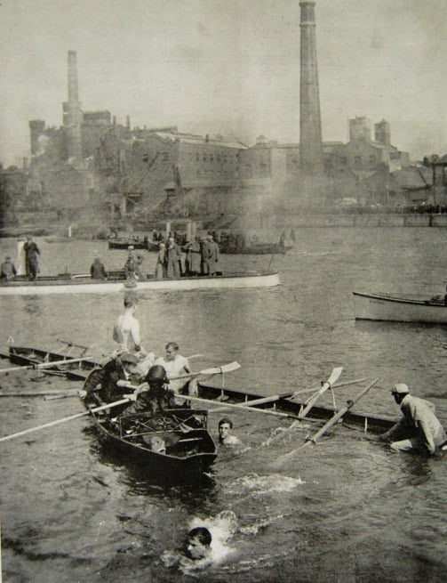The 69th annual boat race was held on 30th March 1912. Oxford went into the race as reigning champions. The race started in a virtual gale with very choppy waters and unfortunately, both Oxford and Cambridge boats sank. To be exact, the Cambridge boat sank and Oxford had to row to the bank and bail out their boat. This resulted in the event being declared a ‘no-race’. Pitman, the umpire, told them that he had called off the race due to the weather conditions. This had upset the Oxford crew as they were still afloat. Oxford won the re-row on the following Monday by six lengths. Most of the crews involved in that 1912 race served in World War I with one man winning the Military Cross.
Celebrations
Mother’s Day
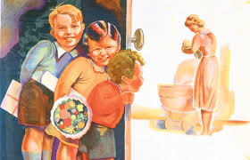The history of Mother’s Day dates back to the 16th century when the custom developed that you paid your ‘mother church’ a visit – either the church where you were christened, your parish church, or the nearest cathedral – and you were said to be ‘going a-mothering’ when you did so. This happened on the fourth Sunday of the Christian festival of Lent. As the dates of Lent vary each year, so does the date of this celebration. The day became known as Mothering Sunday. Servants were given the day off to go back to the parish in which they were born, with children and other family members also joining in. Because this occasion was a rare opportunity for a family get-together, the focus of the day gradually shifted to visiting not just the mother church, but one’s own mother. At the time, it wasn't uncommon for children to leave home to work when they were as young as 10 years old, so this was an opportunity for families to meet up again. Hence, Mothering Sunday in Britain came into being. Although the day fell during Lent, the austerity was relaxed for Mothering Sunday and people treated their mothers to edible gifts such as Simnel cake, ‘mothering buns’ or fig pie. We now tend to call it Mother’s Day which developed in America and has no link to Lent at all.
This year it falls on Sunday 15th March.
What’s happening locally in March
Crufts 5th – 8th March NEC
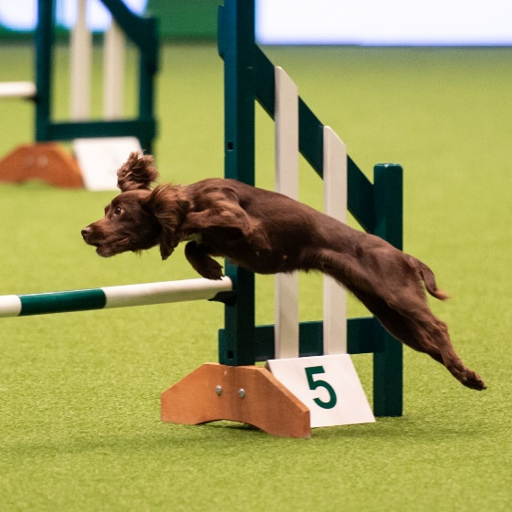Founded in 1891, Crufts is widely recognised as the world’s premier dog show. Crufts 2026, organised by The Kennel Club, takes place at the National Exhibition Centre. This event showcases the finest breeds and their abilities, all following the Kennel Club’s rigorous standards. These standards relate to the ideal characteristics, temperament, and appearance for each breed, ensuring that the dogs are “fit for function” in terms of health and fitness. The four-day event features a variety of competitions including agility, flyball, international grooming, and the grand finale Best in Show. Tickets are currently on sale.
Birmingham Art Gallery - Staffordshire Hoard Free entry (currently open)
Visitors to the Birmingham Art Gallery will have unrestricted access to the Anglo-Saxon treasure. It is the largest hoard of its kind ever discovered and includes hundreds of items buried about 1,400 years ago.
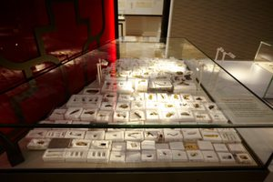Not only are the items on show, there are hands-on displays exploring how these intriguing items were used. Visitors can find out about the craftsmanship used to create the items in the hoard, and learn how the designs of the objects can be linked to many regions across Europe.
Local trivia

Did you know where this tree was planted? It is in Elmdon Park and was supposed to have been planted during the reign of Henry V111! It is an ancient Sweet Chestnut tree, estimated to date back to 1518.
Apparently, during the Second World War the tree escaped the bombing which landed on Elmdon in November 1940, killing several nearby residents.

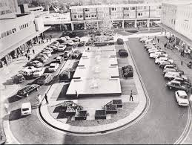A trip down memory lane - who remembers this?
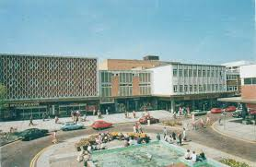

I believe there are plans in place to make sweeping changes to this area again.
If you have anything you would like to add to our newsletters, please let me know
Thanks for reading,
Chris

