February Newsletter
Let me begin by wishing everyone an extremely belated happy, healthy 2026. If you’ve made new year resolutions, I hope they are still going strong!
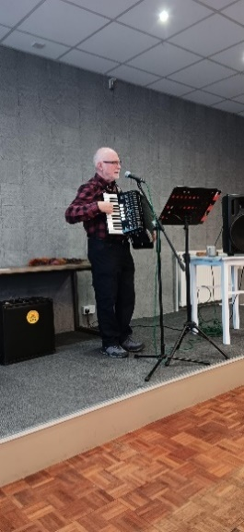
We kicked off 2026 with a fantastic talk by Alistair entitled ‘Enigma Variations’. A great blend of facts and musical interludes. Then Peter gave us a wonderful talk entitled ‘A Travelling Life’ but admits it should have been called ‘A Travelling Wife’! So many countries, so many interesting tales to tell. Thanks to both Alistair & Peter.

This was followed by ‘A Century of Popular Songs’ – 1860’s to 1960’s presented by Richard Churchley & had us all singing & toe tapping along. It’s amazing how many of the very old songs you know!

On January 26th we held our first ever ‘Room 101’ and unanimously, LED headlights were banished to room 101!
In February, we look forward to talks on Bristol, unusual pub names, & the life & times of Billy Butlin; our ‘bring a book’ morning hosted by Alistair and our AGM on February 23rd (not to be missed with refereshments afterwards!). Quite a mix I’m sure you will agree.
One of our valued members, Doug Cross wonders what has happened to the Solihull U3A cluster. The cluster held meeting three times a year with all local U3A’s invited to attend. Jill attended the last one almost a year ago. To prove how useful these were, we made contact with two members from Bentley Heath U3A independently after the meeting, and shared good practice with them. Doug asks:
What has happened to the Solihull Cluster committee meetings? At one time there were 13 U3A’s in the Solihull borough area and the cluster group used to meet together to discuss items that effected all of the groups.
Solihull U3A first met in an informal manner in 1983 & the first official meeting was March 17th of that year. The first chairman was Mary Denby with meetings being held in the old Methodist Hall. With growing numbers Dorridge was formed in 1990 & Arden in 1992. I joined Solihull in 2000 & Angela Gill took over as chairman in 2003. I believe she & I attended the first cluster meeting at that time. I became chairman of Solihull U3A in 2008 & our 25th anniversary was on 25th September of that year.
I became chairman of the Cluster, I think, in 2010. The secretary was from Dorridge & the treasurer from Arden. We met three to fout times a year in the parish hall in Barston. Numbers grew & I was in the chair for ten years. These meetings were so useful as they helped to share good practice across Solihull. The last club to join in my time was Olton. I understand some clubs have folded & joint cluster meetings now seemed to have failed. WHY?
Thanks Doug, & I am on the case, chasing up why the meetings seem to have stopped.
What special things happened in February, I hear you ask
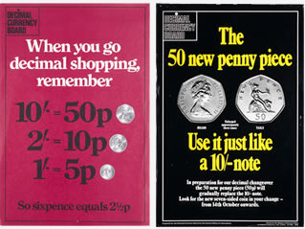
February in history
On the 15th February 1971, Britain went decimal. Remember back to when £1 was 20 shillings and 1 shilling equated to 12 pence and all the things you could buy with an old penny! There were half crowns, florins, sixpences & threepenny bits. I have to say, decimalisation made money maths so much simpler.
Monday 15th February became known as Decimal Day. The Decimal Currency Board had been set up and it ran a public information campaign to help smooth the transition. Currency converters were available for everyone, and prices in the shops were shown in both currencies. Initially, the old and new currencies operated together and people could pay in the old currency and receive change in the new. The phrase often used in the 1970’s became ‘how much is that in old money?’ Did you ever say that I wonder?
Valentine’s day 14th February
Rather than think about the day, I thought I’d focus on Valentine’s cards.
The first documented romantic note was from Frenchman Charles the Duke of Orleans. Imprisoned in the Tower of London in 1415 he wrote the following to his wife:
“Je suis desja d’amour tanné Ma tres doulce Valentinée.” Which translates to: “I am already sick of love, my very gentle Valentine”.
In the early 1700’s, lovers made Valentine cards and they were said to leave these on door knockers or slip them under their recipients’ doors. If you were unsure of what to write, there were guides that you could purchase to help you!
With the onset of the Industrial Revolution, it became much easier to mass produce pre-printed cards and it is said that by the 1820’s about 200,000 Valentine cards were being circulated in London! The cards frequently featured flowers, hearts, birds &, of course, Cupid. With the establishment of the UK’s postal service in the 1840’s – and postage costing just a penny – the mailings more than doubled. Valentines were sent in such great numbers that postmen were given a special allowance for refreshments to help them through the extraordinary exertions of the two or three days leading up to February 14th.
By 1871, 1.2 million cards were processed by the General Post Office in London.
This popularity continues today. It has been estimated that around 25 million Valentine's cards are sent in the UK every year, making it the second most popular card-sending occasion after Christmas.
Recommendations from our members.
Jill Park visited THE AMERICAN MUSEUM, BATH and recommends it as a really interesting place to visit. Read on to find out more.
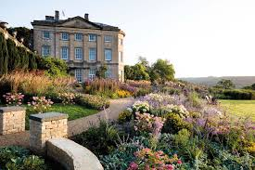
I recently visited the American Museum in Bath. I didn’t know it existed until I went to visit a friend in Bristol and she had arranged for us to go and see it. It’s set in the most beautiful countryside and was so interesting.
The museum was founded in 1961 by Dr Dallas Pratt, an American psychiatrist and collector and John Judkyn, a British born antiques dealer to showcase American decorative arts and showcases arts, quilts and folk arts. Collecting for the museum began in 1958, and panelling and floors were shipped over from America enabling period rooms from demolished buildings to be reconstructed within the spacious interiors of Claverdon Manor.
One of the rooms is Conkey’s Tavern, an 18th century tavern originally sited in a farmhouse in Pelham, Massachusetts. Not much like a pub now but interesting all the same.
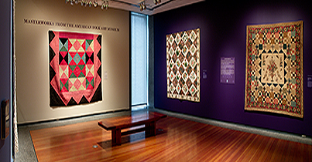
The quilt room is absolutely wonderful. There are beautiful examples of Native American arts and many decades on it remains the only museum outside the United States to showcase the decorative arts of America.

There are beautiful gardens and also a cafe.
The mission of the American Museum and Gardens is to further people’s understanding of the richness and complexity of American culture.
It’s well worth a visit!
Thanks Jill!
What’s happening locally in February
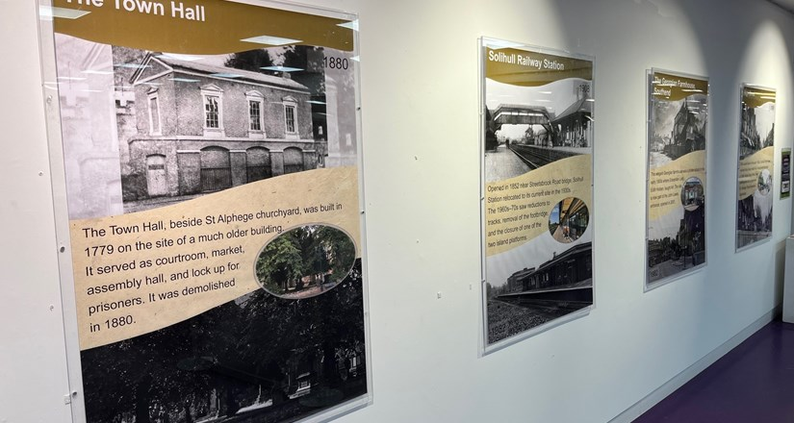
Solihull-A-Journey-Through-Time
This is an exhibition that is free to view in the Heritage Gallery, upstairs at The Core, until 28th February. It is a selection of photographs showing the history of Solihull. The photographs date from the end of the 19th and beginning of the 20th centuries alongside matching images taken in 1982 and 2025.

Hidden Spaces Tours Birmingham Museum & Art Gallery
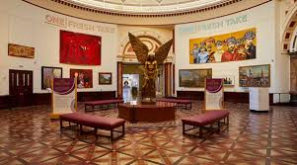
Booking is essential and there is a cost, but you can join a group at the Birmingham Museum and Art Gallery Thursdays and Saturdays to go beyond the gallery walls and into the hidden heart of the Gallery. It is called the 'Hidden Spaces Tours' and you will be able to explore places that are not normally available to the public — including storerooms and architectural gems often overlooked. It will include quirky tales from the Gallery’s past.
Local trivia
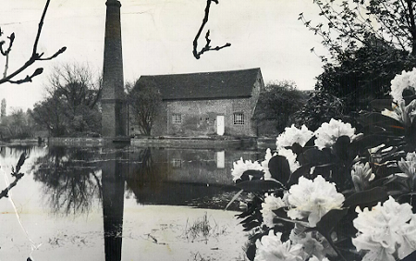
Did anyone recognise the building in this photograph taken in the 1970’s?
Of course it was Sarehole Mill, a Grade II listed water mill, in an area once called Sarehole, on the River Cole in Hall Green. It has been said to have a connection to Tolkien with the mill remaining an enduring symbol of his childhood and the inspiration for the Shire.

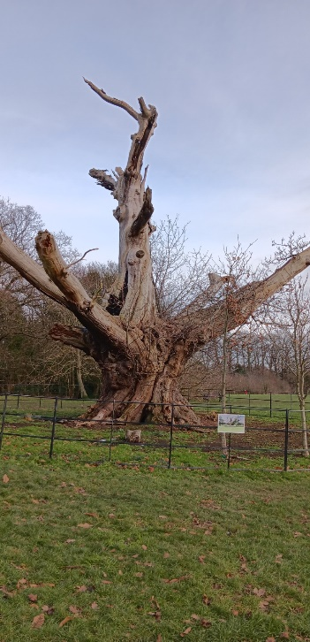
Where in Solihull is this famous ancient Spanish Chestnut (Sweet Chestnut) tree, I wonder, and during which monarch’s reign was it supposed to have been planted?

And finally, I will be standing down as chair of this wonderful U3A at the AGM on 23rd February. It has been an honour and a delight to have been chair for the last two years and it is now time to hand the reins to someone else. I will continue on the committee and the newsletters will keep arriving monthly. I’ve really enjoyed Monday meetings with you and, of course, I'm going to finish with a poem (my limerick) – and why not!?
Solihull U3A is, quite simply, the best
Happily welcoming each new guest
We are such a sociable crowd
Each member does us proud
Come join us, you’ll be impressed!
Thank you to everyone for their support, it has been greatly appreciated
Chris Gilbert

