Solihull U3A Newsletter November 2025
I would like to extend a warm welcome to everyone. The weather is decidedly Autumnal, the clocks have gone back, the nights are drawing in and, I hate to say it; Christmas is looming on the horizon. Time to wrap up warm and enjoy getting out and about with family and friends or cosying up in the warmth of our homes.
Please take a look at our November newsletter and perhaps spend a little time reminiscing your November 5th celebrations from years gone by.
Recent highlights
We had a fascinating talk on October 20th about British birds by Nick Martin. It really made you want to go outside and just enjoy being in nature, observing the local birdlife and trying to identify them. I live in hope of seeing the rare lesser spotted woodpecker or hearing the nightingale’s song! During November we will be finding out more about the Beatles, Richard Lovell Edgeworth, Esperanto, Africa and watching short films on Wordsworth and Sylvia Plath. I think you’ll agree, there is something for everyone there!
Kent trip
The trip to Kent was a great success but I will let Derek tell you in his own words.
Taking Mystery out of History Group Trip - Historic Kent, 12th October 2025
Our itinerary commenced with a guided tour of Crossness Pumping Station, also known as the Cathedral of Sewage, distinguished by its elaborate design and Victorian-era floral ironwork.
We dedicated an entire day to The Historic Dockyard Chatham, starting with a guided tour, after which we were free to explore notable attractions such as the extensive’ lifeboats through the ages’ exhibition, a 1966 spy submarine, two warships, immersive galleries, and the operational Ropery.
At Leeds Castle, we examined its nine centuries of history before proceeding to Whitstable, a town famed for its oysters.
In Canterbury, we toured the renowned Cathedral, a site of significant historical events and pilgrimage.
Our journey concluded at Chartwell, the former beautiful residence of Sir Winston and Clementine Churchill.
We stayed at a really nice hotel, The Bridgewood Manor Hotel and Spa. A good time was had by all!!

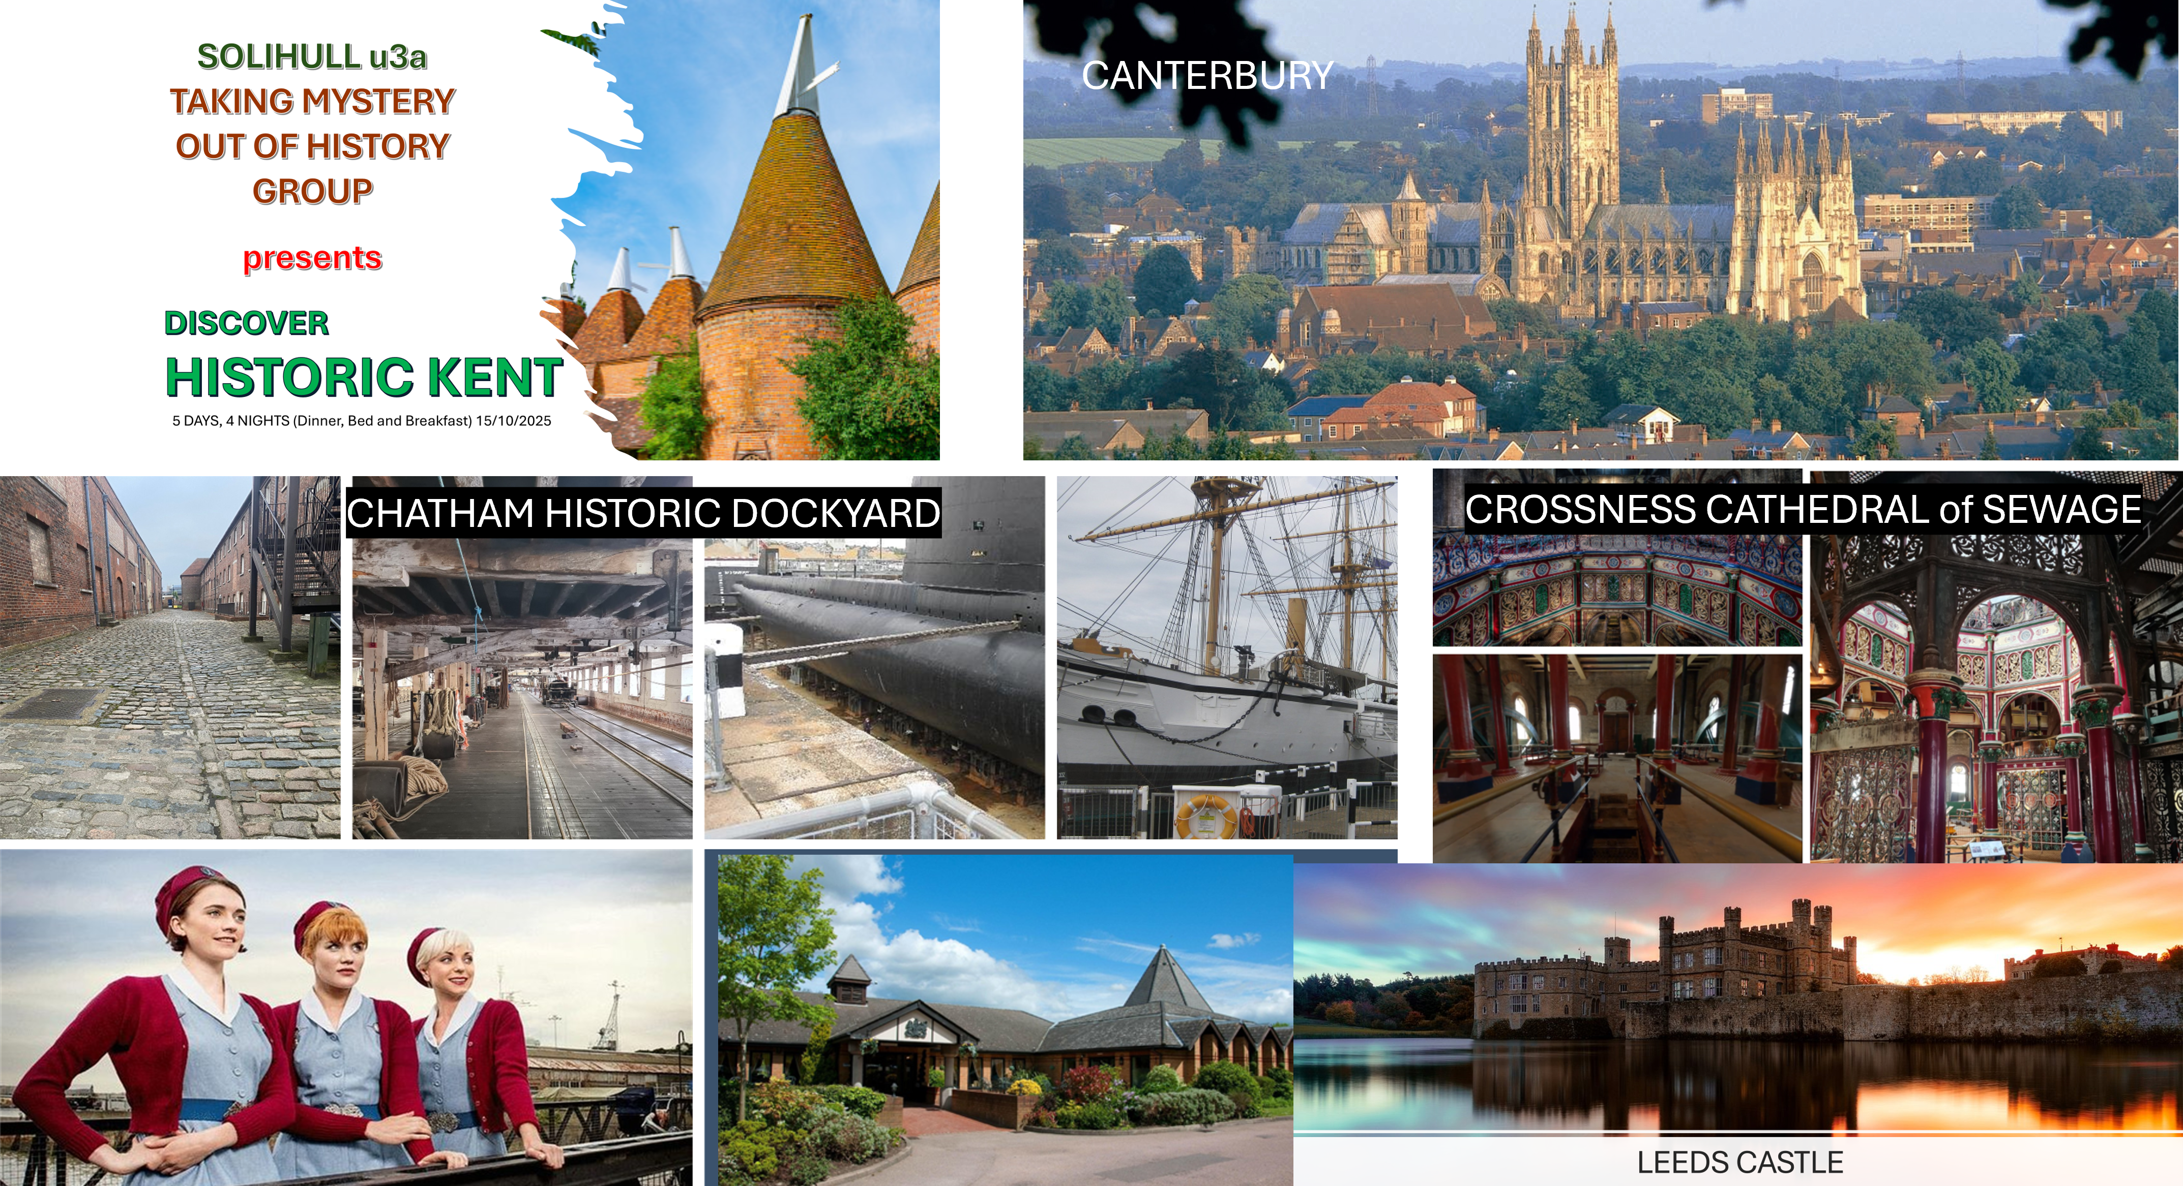
Many thanks to Derek and Penny Hoskins for organising a fabulous trip!
I continue to highlight the wonderful groups that our U3A offers. This month, the spotlight is on the French Conversation group.
The U3A French Conversation Group meet each Thursday at a member's house.
We practice reading, listening and speaking French using a variety of media including podcasts, You Tube films and magazine articles.
The morning is a delightful mix of “bonjours", enthusiastic hand gestures, and the occasional creative attempt at pronunciation. Laughter is guaranteed, mistakes are celebrated, and by the end, everyone leaves feeling a little more Parisian—even if their accent is still more “croissant” than “Champs-Élysées.”
Mary Scott
Thank you, Mary, for this insight into the group. You clearly have a lot of fun!
What special things happened in November, I hear you ask
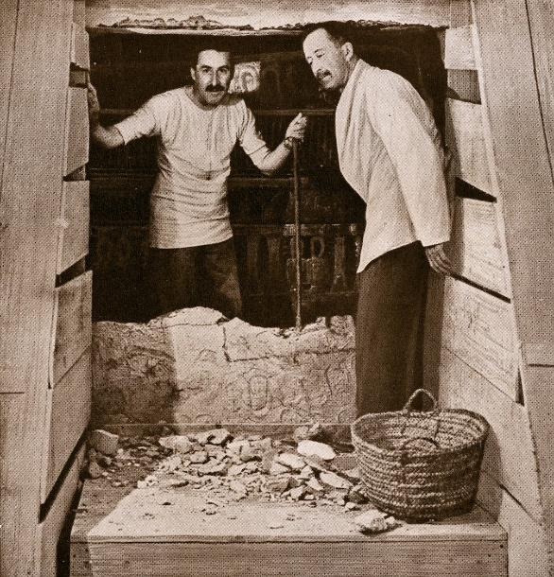26th November 1922
“Can you see anything?”
“Yes, wonderful things!”
These are the famous words of Howard Carter at the moment when he discovered Tutankhamun’s tomb in the Valley of the Kings. The British archaeologist and Egyptologist Howard Carter, holding a candle in one hand, made a tiny hole in the doorway of a tomb. Taking his first look, he peered through a small crevice, revealing for the first time, the contents of Tutankhamun’s tomb. After years of searching, Carter's team found a nearly intact tomb hidden beneath debris, containing over 5,000 artifacts, including the famous gold burial mask, chariots, and furniture.
5th November
Of course, this is Bonfire Night whose origins began with the failed Gunpowder Plot of 1605, where a group of Catholic conspirators, including Guy Fawkes, planned to blow up the Houses of Parliament and assassinate King James I.

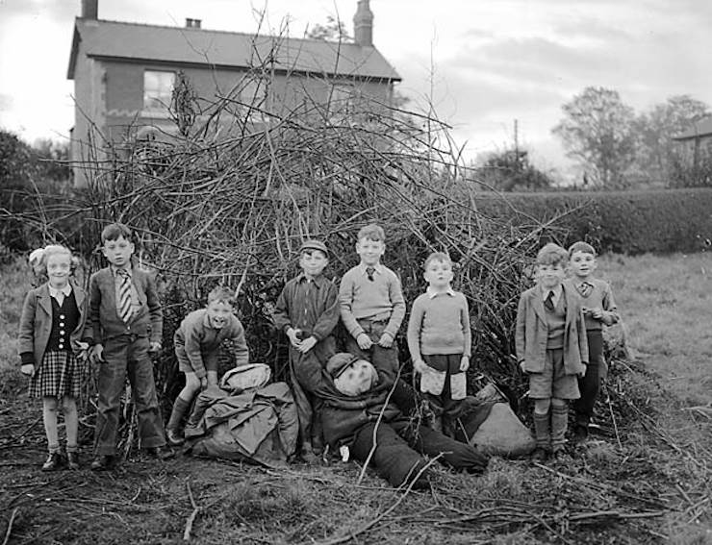But I want to take you on a trip down memory lane when effigies of Guy Fawkes would be made often using old clothes stuffed with newspapers and carted around the streets and the phrase "Penny for the Guy" was shouted on street corners. The money raised would then be spent on bangers and other fireworks 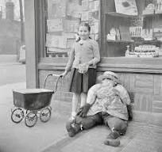which children could go and buy on their own! And who remembers Standard fireworks? Do you remember Catherine Wheels being nailed to a wooden fence and, if not nailed securely, flew off into the air, still spinning! Rockets were launched from glass milk bottles flying off in all directions. Health and safety out of the window! Every child would be given a sparkler to write their name in the air. Roman Candles were particularly popular, as were bangers. Bangers were thrown on the ground to explode, scaring many an unwary adult! These are now banned from sale in the UK, as are Jumping Jacks, another Bonfire Night favourite.
Some special foods you may remember – cinder toffee, toffee apples, parkin (a kind of gingerbread), potatoes roasted in the ashes of the fire and served with butter and salt, and eaten with a teaspoon in gloved hands.
John Phillips has shared some of his memories with us.
The Big Bang
After the war, Janet’s father was chief trainer at Oakdale colliery. Each year he had an intake of 14 – 15-year-old boys to turn into miners, and he had a favourite catch phrase; “All men are boys, and all boys are buggers”. He was right about that. At the time we enjoyed a degree of freedom unimaginable to today’s kids. We ran the streets, fields, mountains and rivers before we started school; we caught and rode ponies, lit fires, fought boys from other areas and sought ways of making explosions – anything to annoy and upset our elders and betters. The high point of the year of mayhem was the run–up to Guy Fawkes night; ready availability of twopenny bangers offered many opportunities for youthful skulduggery. We threw them around, scaring humans and other animals, particularly groups of girls. (Very soon after we discovered the advantages of maintaining good relations with girls),
However, we were not restricted to bangers when wanting to make big bangs – we had access to calcium carbide, a compound which reacts with water to produce the highly flammable and explosive gas, acetylene. We would light a fire, place a piece of carbide in a golden syrup can, add moisture (from a range of sources – you work it out), hammer the lid down tightly, and throw it on the fire. The resulting explosion sent the red-hot can flying in a totally unpredictable direction, and scattered burning wood over an area of 6 – 8 feet diameter. I’d swap a computer game for that any day of the week.

November in the local area:
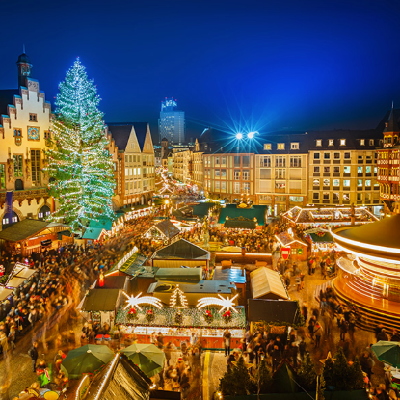Birmingham's Frankfurt Christmas Market:
November 1 to December 24.
The largest German Christmas market outside of Germany.

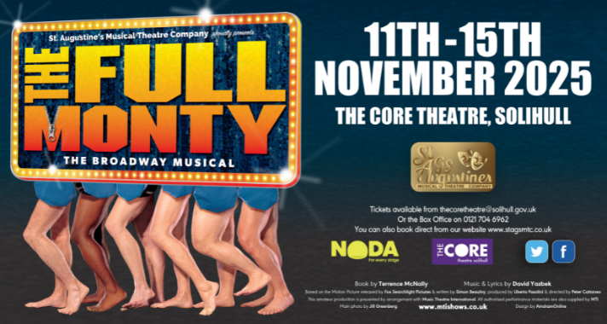
The Core theatre 11th – 15th November
‘St Augustine's present The Full Monty, a story full of heart, with a raucous mix of razor- sharp humour and toe tapping pizzazz.’
Something to make you smile.

Local trivia
In the October newsletter, I shared two photographs. Did you know where they were? See below for the answers
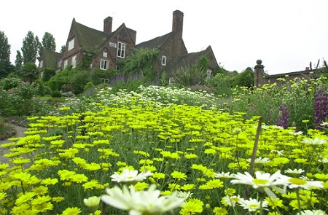

Winterbourne house

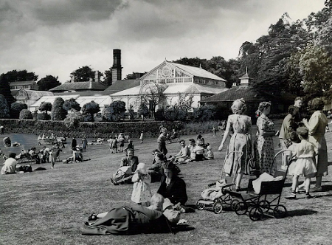
Birmingham Botanical Gardens and the year was 1957!

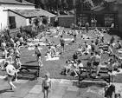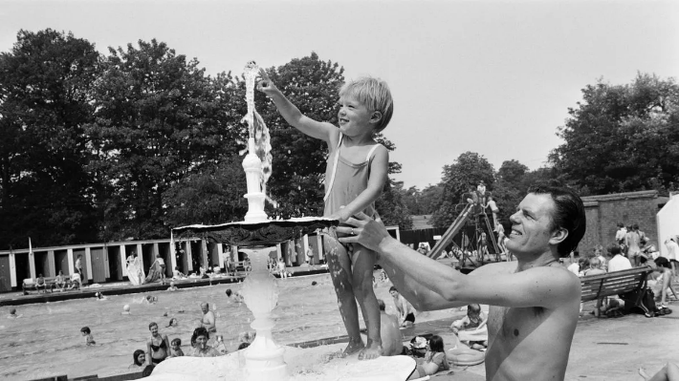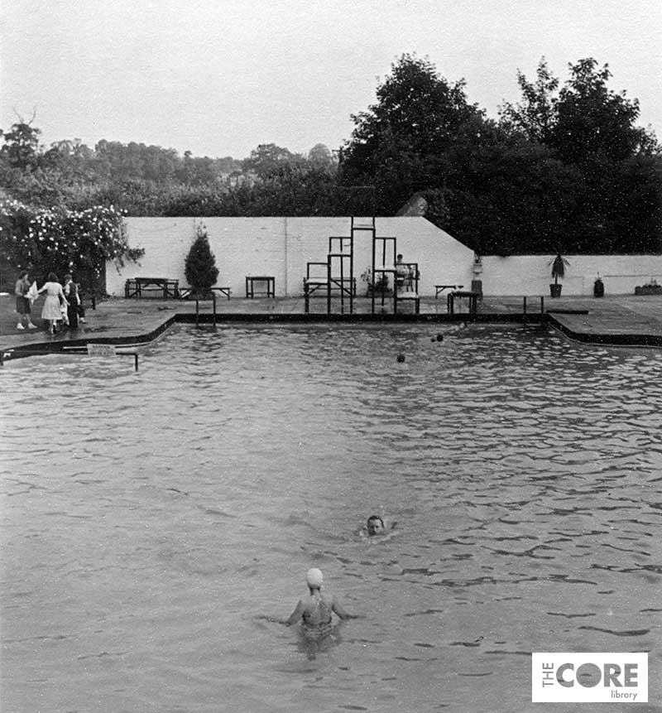Now, who remembers this place in Solihull?

Thanks for taking the time to read our newsletter. If you would like to contribute to the next edition please come and see me. We would love to know what your group have been doing or about a special event in your life!
Chris Gilbert

