Solihull U3A Newsletter October 2025
Welcome everyone to our next instalment – I do hope you enjoyed reading the September edition as much as I enjoyed preparing it. We held our first ‘Would I lie to you?’ quiz on 29th September– and I must say, it was so much fun and who would believe the things our members have done! Some members tell very good lies as well! In the new year we will trial another game – Room 101 – I have to say the person I would put in would probably be quite controversial. Watch this space!
On 6th October, Alistair will host ‘Poetry Please’ – which poem will you choose? Unfortunately, I am unable to attend this meeting so I will share with you my choice, The Wedding poem by Whitney Hanson, to celebrate my daughter getting married in Las Vegas with Elvis!
They say that sometimes
love starts with a spark.
And that might be true,
but if I were to wish you a love,
I wouldn't wish fire for you.
You see, fire is powerful.
It burns bright and then it's gone.
It's beautiful and warm,
but it doesn't last long.
So instead of wishing you a love that burns,
I wish you a love like a river twists and turns.
It changes and it flows,
It is powerful and free.
But it consistently finds its way back to the sea.
And so, like the water,
I hope your love is ever growing, ever changing.
I hope your love is powerful and free,
And may you always find each other,
Like a river finds the sea.

The trip to Kent takes place from 12th to 16th October and I look forward to sharing some of the highlights with you next time. As many members will be on this trip, there will be no Monday morning meeting on 13th October.
I would like to highlight two more of our wonderful groups this time – Yoga and Bridge. Read on to find out a little bit more about what they have been doing lately. Speak to Mary and Ann if you would like to find out more.
YOGA
Every Wednesday morning, the WI hall is transformed into a haven of gentle stretches, laughter, and the occasional creaky joint. Although this U3A yoga class is blessed to benefit from a wonderful and patient fully- trained yoga teacher, the class is less about perfect poses and more about enjoying the moment—whether that means balancing like a wobbly tree or simply remembering to breathe. With cheerful chatter, a few giggles and a shared appreciation for comfy mats, this class proves that flexibility isn’t just for bodies—it’s for spirits too! Mary Scott
BRIDGE GROUP
Our U3A bridge group meets on alternate Monday afternoons in one another’s homes. A wide range of playing skills are found amongst us. There are those who were taught to play at the Bridge Club in Solihull, while others have taught themselves in a rather ad hoc way, some have even taken part in bridge enhancement classes whilst on cruises!
Whatever our skills we enjoy the process of bidding, often having discussions with any one sitting out, and there is a real sense of satisfaction when we make the contract. I can say that at the end of our session we have well and truly exercised our ‘little grey cells’! Ann Berry
Thank you to Ann and Mary for their insight into these two groups.
What special things happened in October, I hear you ask
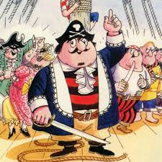The first episode of Captain Pugwash aired on 22nd October 1957. The children's animation was written, illustrated and produced by John Ryan. It was a simple cartoon, with cut-out figures moved by cardboard levers and is still fondly remembered years after it was last shown. The Guardian newspaper wrongly repeated the unfounded myth that the names of the crew all contained sexual innuendo (you may remember what the names were!) and that the programme had been taken off the air for that reason. In 1991 its creator, Ryan, successfully sued The Guardian and Sunday Correspondent and they issued an apology following this.
21st October
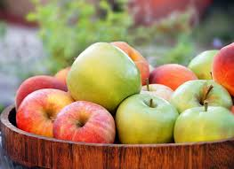Each October 21st, National Apple Day celebrates the cultural heritage and agricultural significance of apples highlighting the rich history of apples, the importance of orchards, and the diversity of apple-based products that are central to many communities. The first Apple Day was held on October 21st 1990 in the old Apple Market in Covent Garden. Since then, Apple Day has been celebrated every October 21st and has spread across the UK through nurseries, fruit farms, restaurants, National Trust and RHS gardens, museums, art centres, community groups and schools.
In other news:
New arrivals
We would like to send warm congratulations to Jill and her family on the safe arrival of their first grandson Finlay Robert (Jill already has three granddaughters). Our best wishes to you all.
Congratulations also to Lynda on the safe arrival of her fourth grandchild, Peggy. Love and best wishes to the family.
And:
Congratulations to Clare and her family on the birth of her new grandchild Cleo Daphne, making this her 10th grandchild! Our best wishes to you and your family Clare.
So many new babies! So exciting!
Best wishes
We would like to send best wishes for a speedy recovery to Hilary’s husband, Mike.

If you have anything special to share with us, whether as an individual or as a group, let me know and I will add it to next month’s newsletter. We would love to know what you have been up to!
October in the local area
Get ready for a feast at the Solihull Food Festival! (solihullbid.co.uk)
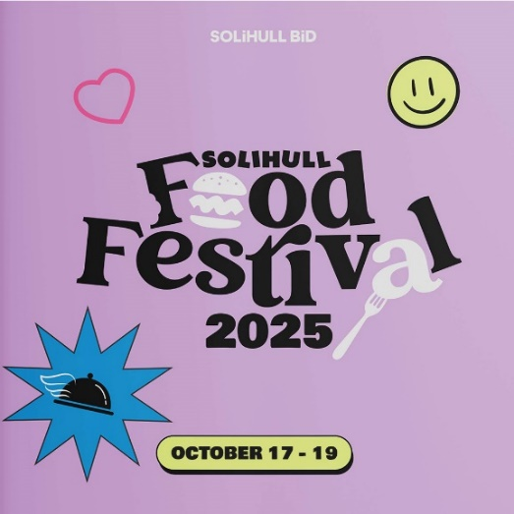
From Friday 17th – Sunday 19th October, Solihull town centre will transform into a food lover’s paradise with something for everyone. Check out the full line-up of activities including music and song and seeing celebrity chefs – Glynn Purnell and Aktar Islam!

NMM “Live” Open Day – Sat 25th & Sun 26th October
The National Motorcycle Museum is hosting Museum Live 2025! This two-day celebration is packed with thrilling shows and attractions for motorcycle enthusiasts of all ages. Step into a world of nostalgia and marvel at one of the world’s largest and most impressive collections of British motorcycles — free of charge! This is your chance to connect with motorcycling heritage like never before.
Local trivia
The answer to last month’s trivia question was The Roundhouse!
This month, I wonder if you can identify these two famous places in Edgbaston, Birmingham and, a bonus question, what year do you think the 2nd photograph was taken in? Answers in our next newsletter.

