Solihull U3A Newsletter September 2025
Hello everyone and welcome to our newsletter, I hope you enjoy reading it.
I am very proud to be the chair of this thriving, happy U3A. There are so many great things that happen that I thought it would be a good idea to share some of them with you. This term we have some very exciting talks alongside the quiz- Would I Lie to You? and poetry and music mornings. We kick off our Monday morning sessions on 8th September with our husband-and-wife team, Alistair and Mary, talking about artists Georgia O’Keefe and Elizabeth Forbes. What a way to start our new term! October 12th – 16th we have a five-day coach trip to visit some very interesting historical places in Kent including Crossness pumping station which is affectionately known as ‘the Cathedral of Sewage’! Something for everyone, I think.
I would like to highlight two of our wonderful groups this time - Playreading and Wine Appreciation. Read on to find out a little bit more about what they have been doing lately.
THE PLAY READING GROUP
We meet every other Tuesday at 2.00pm. It’s usually held at my house and we’ve got ten members. Veronica gets the plays from Coventry Library and we have a mixture of comedy, thrillers and drama. We read in the round so that everyone gets a turn and we can practice our accents if the mood takes us! It’s great fun and we read for about an hour and then have coffee and biscuits and a chat.
Our current play is Quiet Wedding by Esther McCracken. It’s a comedy about the chaotic preparations for Janet and Dallas’s wedding. It’s all too much for Janet’s nerves and Dallas takes drastic action to resolve the situation. It’s very enjoyable to read although our major difficulty is trying to remember what happened when we last read it as it usually takes two or three sessions to finish a play! I enjoy the crime dramas very much. So far this year we’ve read:
The Homecoming by Harold Pinter
Midsummer Mink by Peter Coke
Afternoon at the seaside by Agatha Christie
Not now darling by Ray Cooney
Collect your hand baggage by John Mortimer
The Prime of Miss Jean Brodie adapted from a book by Muriel Spark by Jay Presson Allen
No Shakespeare yet but who knows?
Jill Park convenor of the Play Reading group

WINE APPRECIATION GROUP
The Wine Appreciation Group is preparing to re-launch itself this autumn after a summer break. This term we will be tasting wines from the Rioja region of Spain ("Rioja and Roll") and from Australia ("Wizard Wines from Oz"). We will also be staging a Blind Tasting of some supermarket wines. In every blind tasting that we have previously held, the cheaper wines from Aldi have been more popular than those from Tesco, Morrisons, Marks & Spencer and even Waitrose. This either indicates that Aldi sell superior wines at bargain prices, or that the members of our group don't have very sophisticated wine palates!
We meet monthly at our house to taste six wines, three white and three red. We enjoy our wine but we don't take ourselves too seriously. Informally we refer to the group as the WAGs or the Winos! We do discuss the wines, but as the evening progresses the conversation tends to move on to other topics. We have tasted wines from around the wine-producing world: Europe, North and South America, South Africa, Australia & New Zealand, so far none from Asia!
Each year we have a Christmas meal, and in January we celebrate the birthday of Scotland's national poet with a traditional Burns Night, at which we taste some whisky as well as the wine.
Our numbers are somewhat restricted by space, but if you would be interested in attending one of our meetings, please do have a word with me.
Alistair Scott, convenor of the Wine Appreciation Group

In other news:
Award time
In June, one of our longest serving members, Anne Hand, received a special award for her services to the NSPCC having clocked up 44 years of volunteering at the NSPCC District at Knowle and Dorridge! In the Knowle Observer, Amanda Synnott, the NSPCC’s community fundraising manager for the West Midlands praised the dedication of Anne and her colleagues, saying it was inspiring: ‘proving that a small group of people’s kindness can ripple out and transform a community’. Well done, Anne, what an achievement! We are sending our best wishes for a speedy recovery as we know you have not been well recently.
History Group & The Kings Trust
The History Group meets in the Solihull Methodist Church Hall, on the first Tuesday morning most months for talks given by members. We take coffee and cold drinks with us and have a break halfway through the morning.
One of our meetings this summer coincided with a course organised by the Kings Trust. This course was designed to help young people gain confidence. We were asked if the attendees could bring us some cakes and socialise with us during our coffee break. This would help them to gain confidence talking to older people.
During the morning there was a delicious smell of baking wafting in from the hall kitchen. Six young people joined us each carrying a plate of cakes they had just baked. They circulated among us for about 30 minutes.
We enjoyed talking to them and of course eating their scrumptious bakes.
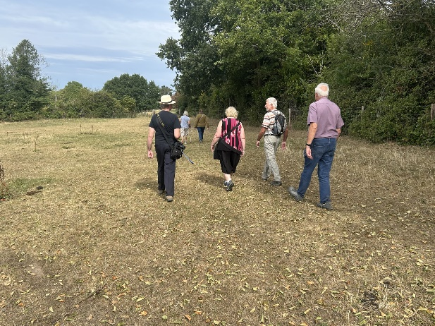
Walking Group
Our new walking group took their first steps around Balsall Common on Friday 22nd August. Seven walkers took part, ably led by Tony but ten attended the lunch afterwards! An enjoyable time was had by all. We look forward to more walks in the future!

Solihull British Legion Summer Fete
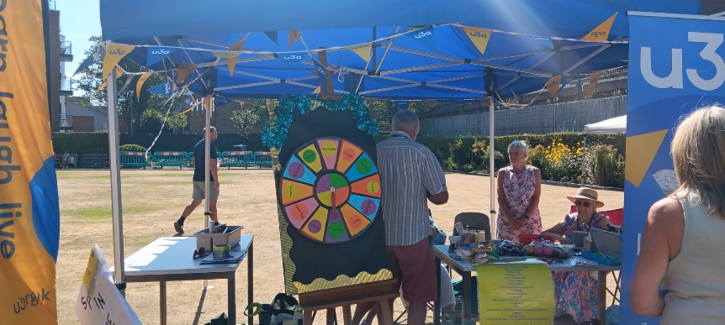
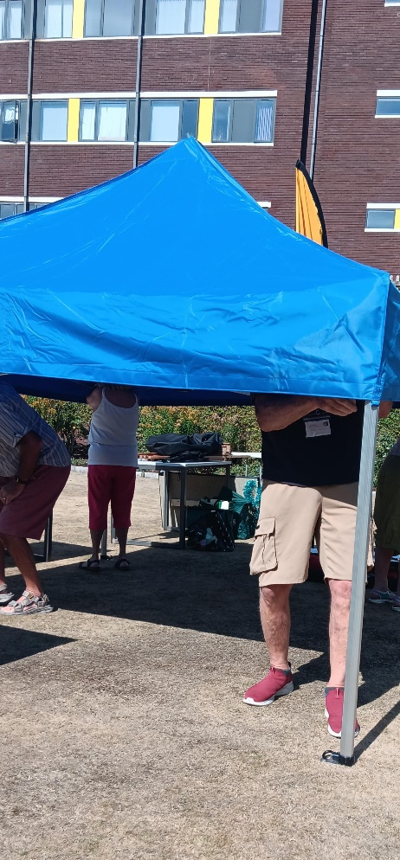
On August 25th the sun shone on us and our stall at the fete. We had several willing volunteers who helped out during the day. Unfortunately, very few members of the public turned up but that didn’t dampen our spirits and we promoted our U3A as much as possible. Thank you to everyone for their support.

Teamwork makes the dream work!

What special things happened in September, I hear you ask

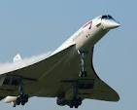
Well, on 26th September 1973, Concorde’s inaugural crossing of the Atlantic took place. Concorde, the world’s first supersonic passenger plane, made its first transatlantic crossing in a record-breaking time of three hours and thirty-two minutes! British Airways Concorde made just under 50,000 flights and flew more than 2.5m passengers supersonically. With a take-off speed of 220 knots (250mph) and a cruising speed of 1350mph – more than twice the speed of sound. In November 1986 a British Airways Concorde flew around the world, covering 28,238 miles in 29 hours, 59 minutes.
Plus:
Roald Dahl Day is celebrated annually on September 13th, the author's birthday, to honour his works and contributions to children's literature.
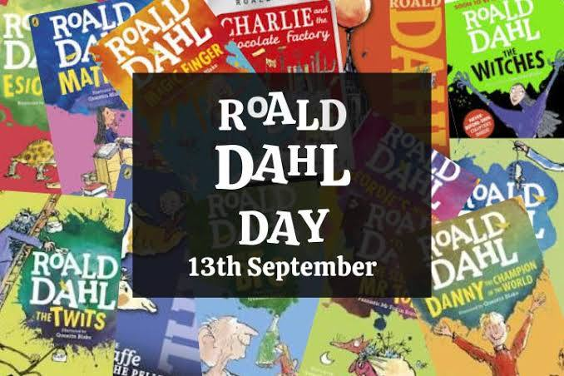
In 1943, Roald wrote his first official story aimed at children. It was called The Gremlins and was inspired by his time as a pilot. The story was about a bunch of naughty little creatures called Gremlins, who would cause all sorts of mechanical problems on aeroplanes. It later became the inspiration behind the hugely popular film Gremlins, which was produced by famous Director Steven Spielberg in 1984.

September in the local area

Studio Kavachi Exhibition at Solihull Library Wed 3rd - Sat 20th September (free entry)
The Courtyard Gallery exhibitions. Swati, the artist behind Studio Kavachi, showcases her dynamic and vibrant paintings in this new exhibition.

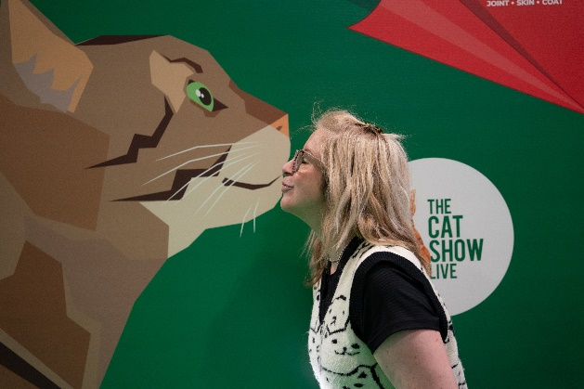
The Cat Show Live 2025 National Exhibition Centre 13th September 2025 from £21.00
Here’s what’s in store: Over 100 stalls packed with cat treats, toys, and more, 175 cats to meet and fall in love with, rescues and charities to support and two theatres packed with seminars, shows, and exciting features
Birmingham Heritage Week 12th – 21st September 2025
There are many activities going on across Birmingham including walks, plays, tours and so much more. Take a look at the website to find out more: birminghamheritageweek.co.uk

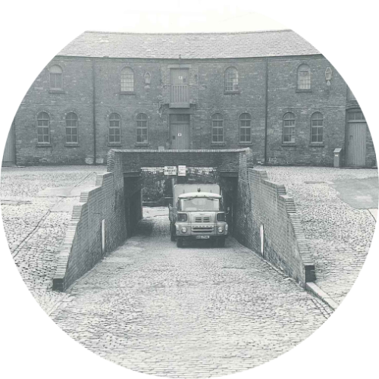
Old Birmingham trivia

What building is this?

Answer will be on the website at the end of September – did you recognise it?

Thanks for taking the time to read our newsletter. Remember to join us every Monday morning starting 10am at The Royal British Legion, Union Road just behind the WI Hall.

